King’s Bounty
Rules of Play
- Players must make a blackjack wager in order to participate in the King’s Bounty side bet.
- Casinos set the minimum and maximum bets.
- Players make the King’s Bounty side bet by betting in the marked area.
- The dealer follows house procedures for blackjack.
- When each player and the dealer have two starting cards, the dealer settles King’s Bounty wagers.
  - Exception: If a player has two Kings of Spades and the dealer has a potential blackjack, the dealer will settle that bet at the end of the round.
- Example of King’s Bounty payouts below:
 | 
 | 
 | 
 | 
 | 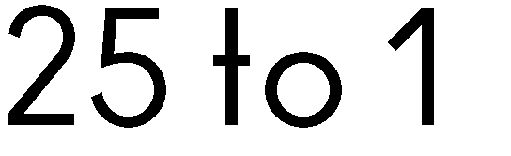
 | 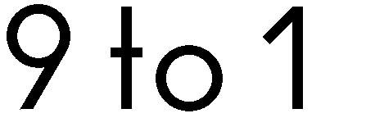
 | 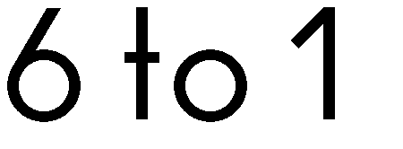
 | 